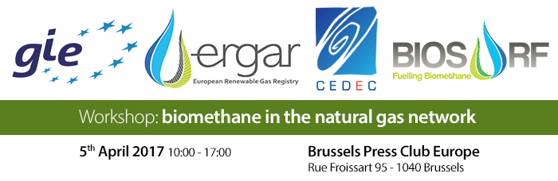
Agenda
Session 1. 10:00 – 11:15
- Greetings and overview of biomethane in the European gas grid
Malene Hein Nybroe (Chair GIE Sustainable Future WG, Energinet.dk)

- Greetings and overview of biomethane production routes
Jan Stambasky (President, EBA)

- The importance of Europe-wide distribution of biomethane for further expansion in the use of LNG/CNG in the transportation sector
Andrea Gerini (Secretary General, NGVA)

Coffee break 11:15 – 11:30

Session 2. 11:30 – 12:30

- Renewable gases in the Commission proposal for the future Renewable Energy policy
Bernd Küpker (Policy Officer, EC DG ENER)

- ERGaR: Tool for cross border transfer and mass balancing biomethane within the European natural gas network
Jeppe Bjerg (President, ERGaR)

Lunch break 12:30 – 13:30

Session 3. 13:30 – 15:00

- ERGaR: cross-border transfer of environmental characteristics of biomethane
Attila Kovacs (Secretary General, ERGaR)

- The ERGaR organisation
Martina Conton (Assistant Secretary General, ERGaR)

- Experience from cross border biomethane trade
Mikkel Kynde (Portfolio Manager, NGF NE)

Coffee break 15:00 – 15:20

Session 4. 15:20 – 16:30

- European biomethane standards for grid injection and vehicle fuel use
Arthur Wellinger (Senior Adviser, EBA)

- CertifHy – Developing a European guarantee of origin scheme for green hydrogen
Wouter Vanhoudt (Director for Europe, Hinicio)

- Closing remarks
Jan Stambasky

This workshop is supported by the Horizon 2020 BIOSURF (BIOmethane as Sustainable Renewable Fuel) project. Website: www.biosurf.eu

